Sarbanes-Oxley Act of 2002

Jonathan Javier
Sarbanes-Oxley Act Analysis
May 4th, 2016

Table of Contents
Introduction 1-2

History of the Act 3-4
Public Policy Prescription 4-7

Implementation of Sarbanes-Oxley 7-9

Impact on Business and Society 9-12

Policy Analysis 12-14
Recommendation for Future Policy Makers 14-15

Conclusion 15

Appendix I 16-20

Appendix II 21

References 22-23

Introduction

In 2002, the Sarbanes-Oxley Act was enacted as a United States federal law. Also known as the Public Company Accounting Reform and Investor Protection Act, the SOX was implemented in order to address the accounting scandals of several firms including Enron and WorldCom. The SOX consisted of “disclosure requirements, rather than corporate governance mandates, which were traditionally left to state corporate law and were not part of the federal securities regime” (Romano, 2004). Although many companies flourished in the 20th Century, the accounting scandals of these firms influenced the establishment of the SOX in order to make sure investors were not being negatively affected by fraudulent activity.
I chose this law because I am interested in seeing how the accounting scandals of great companies like Tyco, Enron, and WorldCom led to bankruptcies that ultimately affected investors’ trust in the financial markets. I am very interested in investments and want to understand the background of laws and regulations that have taken effect to protect investors from fraud. I have currently invested in several public companies including Nike, Starbucks, and Fitbit, all whom have taken the steps to make sure their investors know what steps they are taking to make sure they not only maximize in profits but also for their investors to know that they are in good hands. I want to bring the reader’s attention to how and why the SOX was created for the betterment of businesses and society.
The purpose of this analysis is to understand the SOX and learn more about how it has affected the financial market. It examines what events lead to the creation of the SOX and how it was implemented in response to a market failure. The law is important because it brings investors awareness to fraud and accounting scandals. Before the SOX was implemented, investors lost billions of dollars due to the accounting scandals of large corporations with fraudulent financial statements. By looking at the history of the act, we can see why the SOX was necessary to help investors and restore confidence in the general financial market.
The paper’s structure first goes into detail about the law’s implementation and background information. It will go into what steps it took to implement the SOX Act and why it was necessary for the good of the general public and other companies. Then the paper will describe the effects that the SOX, showing its strengths, weaknesses, and impact it has had on society and businesses since its implementation. SOX has been able to tremendously improve the ways that companies are run, focusing on not just maximizing profits but also having a sense of corporate social responsibility. This analysis intends to give the reader knowledge of the SOX act and what its impact has been on society and businesses. It has been able to give investors and employees protection from fraud and accounting scandals. Lastly, this analysis gives future recommendations for policy makers to follow so that there less controversies and debates over acts that are passed.
My motivation for writing about this law is my love for the accounting field and investment background on certain corporations. Throughout my college years, I have always wanted to learn more about how to invest in companies that have long-term goals for profits and expansion. Warren Buffet, one of the wealthiest investors in the world, got me interested in the world of finance, accounting, and investments because he was able to research several large corporations and know which direction they were headed to long-term. By researching the SOX Act, I am able to see what measures have been taken place in order to keep large corporations in line and to see how they now are helping not only themselves, but instead act for the betterment of the community.

History of the Act
The Sarbanes-Oxley Act was first implemented on July 30th 2002 to address the scandals of firms in the 1990s to early 2000s. Although companies were generating tons of revenue and investments from individuals, the accounting scandals of corporations like Enron, Tyco, and WorldCom lead to the decline of the economy in the 20th century. When the stock market crashed and investors lost public confidence and money, two senators named Paul Sarbanes and Michael Oxley developed and drafted the bill in order to “protect investors by improving the accuracy and reliability of corporate disclosures” (Sarbanes, 2002). Although Sarbanes and Oxley were a part of two different political parties, Republican and Democrat, they were able to implement ideas for the betterment of society and businesses as they “aimed at enhancing public corporate governance, management, and board responsibility, and transparency” (Sarbanes, 2002).
Enron, one of America’s largest corporations in the 20th century and considered as a “chip stock”, was one of the reasons why the SOX was put into effect to address its accounting scandals and fraud. Enron’s stock price was over $90, then plummeted to less than $1 and ultimately filed for bankruptcy. Aspiring to be one of the world’s greatest companies, Enron’s higher management and executives used fraudulent information in order to “pocket millions of dollars while carelessly eroding the life-savings of thousands of unwitting employees” (Sims & Brinkmann, 2003). They left off approximately $74 billion of debt on their balance sheets, giving its shareholders a tremendous loss in stocks and profits which lead to the loss of thousands of jobs and retirement plans. Kenneth Lay and Jeff Skilling, the CEOs at the time, were the so-called “masterminds” of this plan, which worked at the beginning but was eventually caught on by several investors and financial analysts. The scandal occurred due to Enron’s management using special purpose entities (SPE), which were used to hide any company assets that lost a substantial amount of money off their balance sheets.
Enron was not the only large corporation who used fraudulent information to scam its investors and shareholders; companies such as WorldCom and Tyco were also involved in similar scandals. These companies ultimately caused the loss of investor confidence towards companies, causing the government to step in and address these scandals. This is why the SOX matters; it was created to address the issues that investors and employees faced when investing with large corporations and to spot out suspicious activity.
Public Policy Prescription
These large corporations provided thousands of jobs and helped expand the market through its growth. They had reputations of being consistent, whether it was during good or bad times. However, these large corporations such as Enron, WorldCom, and Tyco had extremely high profit margins on their balance sheets that prompted investors and other individuals to look in depth at their finances. Due to the fraudulent accounting entries of these large corporations, it seemed as if they were profitable and had more profits than they actually had. They were able to pocket millions of dollars as a result, taking money away from its shareholders, workers, and investors.
There are many reasons why market market failure occurs, one being through the abuse of power with monopolies. Market failure can be described as “the pursuit of private interests that does not lead to an efficient use of society’s resources” (Jasso, 2009). By altering balance sheets and giving investor fraudulent information, it allowed CEOs of these large corporations to give them the competitive advantage and ultimately more business power over its investors and employees. Dr. Jasso describes this type of market failure as information asymmetry, or when one party has superior and better information than the other party. Information asymmetry occurred with Enron because higher executives and management hid information from its investors and employees in order for their own personal benefit. By giving fraudulent information to their investors and employees, many individuals thought that Enron was doing very well in the market and was there for long-term.
Due to the invalid and fraudulent balance sheets that showed Enron was soaring in profits, investors and employees invested even more money into the company, not knowing that the company was close to bankruptcy. They created a complex corporate government network, being able to “attract large sums of capital to fund a questionable business model, conceal its true performance through a series of accounting and financing maneuvers, and hype its stock to unstainable levels” (Healy & Palepu, 2003). By persuading and not allowing employees and investors to sell their stocks, it allowed Enron higher management to sell their stocks for profits while others suffered consequences. Enron’s stock from the year 2000 to 2002 is shown in the figure to the right, showing their plummet from almost $90 a share to $0. Enron executives had the knowledge of knowing that their company profits were too good to be true but instead of acknowledging and bringing awareness to their investors and employees about the issue, they continued to encourage even more investments into a company with substantial amounts of debt. This caused the corporate scandal which lead to the arrest of Enron’s executives and jail time for many years to come. This is an example of a market failure because it gave higher executives an edge over their investors through fraudulent balance sheets and abuse of power. By utilizing their position of power, this example of information asymmetry shows how individuals use power for their own personal gain.
Another example of a market failure has to do with network externalities. A negative externality is defined as an opportunity cost that is not considered to benefit society as a whole and affects a third party not involved in the decision process. Negative externalities are seen in the large corporations involved in the accounting scandals that lead to the drafting of the SOX. By giving investors and employees fake information and altering their balance sheets, it created a negative externality because higher management’s decision to lie about their company caused the downfall of not just the company as a whole, but also profits for the employees and investors. By choosing to give investors and employees information for their own benefit, higher management was able to profit off the consequences that were given to others even though they were not directly involved in the decision process to provide the fraudulent information. Not only did they encourage their investors and employees to invest more money in the company stock even though it was millions in debt, but ultimately eliminated their retirement plans and lead to unemployment of loyal workers to make up for the substantial costs.
Negative externalities heavily favor one party over another, leading to an inefficient output of resources. These resources in this case had to do with profits and compensation, ultimately messing up employees and investors with the loss of more than 20,000 jobs and compensation plans; however, this was not the only consequence of unethical choices from Enron’s higher management. It resulted in the loss of public confidence towards companies, causing tension and skepticism with investors and employees. These scandals caused the trust between the companies and its shareholders to be extremely weak as no person wanted to lose their money to a company that was millions of dollars in depth.
Although these accounting scandals occurred, the government intervened and took measures to protect investors by passing the Sarbanes-Oxley Act of 2002. The SOX has then been able to create “new incentives for firms to spend money on internal controls, above and beyond the increases in audit costs that would have occurred after the corporate scandals of the early 2000s” (Coates, 2007). This ultimately resulted in increasing the public’s confidence and trust in companies because it created financial transparency and laws that regulated when fraud was taking place in a firm.
Implementation of the Sarbanes-Oxley Act
The Sarbanes-Oxley Act was first drafted by Maryland Senator Paul Sarbanes and Representative Michael G. Oxley in 2002. Known as the Corporate and Auditing Accountability and Responsibility Act, the bill was drafted as a “reaction to a number of corporate and accounting scandals including those affecting Enron, Tyco International, Adelphia, Peregrine Systems, and WorldCom” (Act, 2002). Due to these accounting scandals, investors lost billions of dollars in shares as it created a stir in the public confidence towards large corporations and businesses. The law was enacted on July 30, 2002, as Congress passed the bill with ease. The act was almost unanimously approved in the Senate with a vote of 99 to 1 while in the House of Representatives, it was passed with a vote of 421 to 3 and 8 abstaining. It was then sent to the executive branch, where the president at the time, George W. Bush recognized the bill as a law. There are 11 titles, or sections, included in the SOX which address corporate social responsibility and the implementation of the Securities and Exchange Commission to oversee companies and requirements for companies.
There are several titles of the SOX that address the requirements for balance sheets, income statements, and other financial reportings. For instance, Title I of the SOX contains nine sections, including the creation of the Public Company Accounting Oversight Board. The PCAOB as a “private-sector, nongovernmental body funded by the public companies and investment companies that benefit from independent audits” and is overseen by the Securities and Exchange Commission (Carmichael, 2004). The PCAOB overlooked and gave regulations to audits while inspecting the quality of financial statements so investors and employees would not be scammed.
Another important title, Title III, consists of eight sections in which higher management should utilize corporate social responsibility. Its goal is to implement CSR into companies and to “align a company’s social and environmental activities with its business purpose and values” (Rangan, Chase, Karim, 2015). This implementation in turn created not only more profits for companies but also an increased positive reputation while helping society as a whole.
Title VI includes four different sections in order to build investor confidence towards financial investors, brokers, and other advisors. Known as “Commission Resources and Authority, it takes a look into current financial advisors to see if their practices are ethical and just for their clients. The SEC oversees these practices and are the authority in deciding whether or not these professional analysts are component to help benefit shareholders and individuals looking into investing in companies.
The last title, Title XI, delves into Corporate Fraud Accountability. It includes seven sections which justifies whether or not crimes are committed by corporations in regards to fraud or accounting scandals. This title ultimately revised the guidelines set for corporate fraud accountability while also increasing its penalties if standards are not met. If there are any questionable or fraudulent activities that the SEC deems as suspicious, they can take a look into the company’s accounts and transactions, ultimately cancelling unusual payments.
The federal agency that is in charge of the administration and enforcement of the law is the Securities and Exchange Commission, or the SEC. They are responsible for enforcing the laws and regulations that are included in the SOX. They regulate requirements that companies should meet in regards to audits and financial statements, keeping an eye for suspicious corporations and transactions. The SEC ultimately reports public companies to “promote social transparency comparable to the financial transparency that now exists” and the social disclosure of information (Williams, 1999). This helps investors and employees see the actual financial statements of companies they are investing in or work for, reducing accounts of fraud and loss of profits. Transparency is key because information from public companies should be available to the public so they are able to make an educated decision to invest in the company or withdraw their shares if they see that they are not doing well.
Impact on Business and Society
The Sarbanes-Oxley Act, debated by several individuals about its implementation and effectiveness, has been able to restore investor confidence and reduce several accounts of fraud from various corporations. It has encouraged a trustworthy stock trading market while influencing more ethical behaviors from large corporations in regards to their balance sheets and profits. The SOX has implemented regulations which companies should follow in order to choose ethical practices, which result in increased investments, profits, and capital. Through integrity and just decisions, these companies are aware of their social responsibility and the decisions they make that will affect others. By following Archie Carroll’s Pyramid of Corporate Social Responsibility, companies can follow a philosophy that not only helps maximizes profits, but also helps societies and communities.
At first, businesses would follow Milton Friedman’s philosophy, which looked to maximize profits and profits only. Milton Friedman described his philosophy as acting “in some way that is not in the interest of his employers” if social responsibility were put into effect because it is taking away profits from corporate executives (Friedman, 2007). However, companies are leaning towards Archie Carroll’s Pyramid of CSR, which includes philanthropic, ethical, legal, and economic responsibilities. By following Archie Carroll’s philosoph, companies can implement social responsibility as a reality where “more managers become moral instead of amoral or immoral” (Carroll, 1991). His philosophy has to do with not only maximizing profits but also helping society as a whole, leading to increased confidence and trust from the general public. By giving back to the community, companies will receive an even better reputation along with building goodwill towards others that will ultimately lead to more profits. If a company only focuses on maximizing profits and does not take into consideration corporate social responsibility, the company will ultimately falter its path to future success. An example of a company that utilizes CSR in their business model is Nike. Nike, although using value-based pricing in their products in order to maximize profits, has an increasingly positive reputation not only because of the quality of their products but also what they do to give back to the community. A few years ago, Nike alongside the Gates Foundation and the U.S. President’s Emergency Plan for AIDS Relief contributes substantial amounts of money to help reduce cases of HIV infections in women. This shows that Nike cares about society and gives back to the community, whether it is through charitable donations or volunteering for great causes. Companies should follow in other companies’ footsteps who utilize corporate social responsibility in order to help others and not only focus on maximizing profits.
Not only did the Sarbanes-Oxley Act create better reputations and goodwill for companies, but it also created the concept of giving back to the community through creating shared value. The concept of shared value, which “focuses on the connections between societal and economic progress”, is critical in order to improve society and the economy, unleashing the next wave of global growth (Porter, Kramer 2011). Shared value defines markets because it “enhances the competitiveness of a company while simultaneously advancing the economic and social conditions in the communities in which it operates” (Porter, Kramer 2011). This shows that CSR is important for companies to implement because they must be willing to step up to the needs of society to maximize profit while also having a sense of giving back to the community. The SOX has increasingly influenced the use of CSR so that companies can be profitable while also having an impact on society. The SOX has eliminated unethical and unjust behavior from corporations so that the public can build trust and confidence again in the companies they invest in.
Policy Analysis
The Sarbanes-Oxley Act was passed about fourteen years ago and has had a huge impact on financial statement overviews and ultimately improving the public’s confidence along with companies choosing ethical choices. The SOX has been successful because it was able to find suspicious activity and decrease the amounts of fraud in financial reports, creating transparency between investors and companies. This ultimately improved public confidence along with building trust between the investor and the company. It has also improved the internal control environment as it has built mission statements to be more ethical and abide by the regulations that the SOX inputted. Corporations must follow these regulations or they will face severe penalties from the SOX, which keeps these corporations in check and making sure that there are no accounts of fraudulent activity. Due to the creation of the SOX, investors are now confident to invest their money back into the U.S market as rarely any large corporation scandals have occurred since its implementation.
The SOX has many strengths that enable it to benefit companies in future generations. One important strength from the SOX is building an ethical climate by being influenced to choose choices that will not only help the company but also benefit society as a whole. By utilizing ethical practices in corporations, it not only helps the company maximize profits but also creates an environment where investors want to trade in and ultimately helps with increased buyer confidence. Also, the SOX helps with eliminating accounts of fraud and suspicious activity from large corporations. Since its implementation, there have been significantly lower accounts of fraud and scandals involving investors and companies, leading to increased profits for both their employees and investors. The SOX is in charge of making sure that corporate fraud will not take place in years to come, ultimately building on buyer trust and confidence to invest in these companies due to the protections the SOX gives to them.
Even though there are many strengths of the SOX that helped maximize profits and reduce suspicious activity, there is one section that has remained controversial over the years. Section 404, listed under Title IV of the SOX, requires issuers to “publish information in their annual reports concerning the scope and adequacy of the internal control structure and procedures for financial reporting” (SOX Law, 2002). Although it may increase accuracy of financial statements and ultimately help build public confidence and trust, the Section allows for a significant cost towards businesses as the “costs of regulation clearly exceed its benefits for many corporations” (Carney, 2006). The significant cost is known as the compliance cost, which costs significantly more if the company is larger, ranging to millions of dollars. Due to the SOX, critics complain that the compliance cost stunts the growth of the company and of various financial firms, taking away profits that should in turn benefit the company and can be used for better reasoning. Even smaller firms who turned public could not afford some of the costs that came with the SOX, causing them to withdraw from the public market. Due to the high compliance cost that made it strenuous on companies to stay in the public market because they could not afford it, the Jumpstart Our Business Act (JOBS Act) was enacted. Signed into law by President Barack Obama on April 5, 2012, the JOBS Act “dramatically changed the landscape for many companies raising capital” by giving the option for smaller businesses or individuals who need financing for their projects or ventures to raise money through ways such as crowdfunding (Stemlar, 2013). This ultimately helped smaller and newer firms affected by the SOX to be able to run their company public. Another weakness involved in the SOX also has to do with Section 404 with the idea of using valuable resources such as time and money that ultimately takes away from the whole company. By putting forth more time commitment and resources to comply with the requirements of the SOX, companies may diverge and lose profits because they are not focused on running the company as they want to but as the government specifically wants with its regulations. Ultimately, the SOX Act may provide these weaknesses to companies but in turn provides more benefits than costs in the long run.
Recommendation for Future Policy Makers
My recommendation for future policy makers is to weigh the pros and cons of implementing a specific law that will not only affect businesses and the way they are run, but also how it affects the community and investors. By utilizing a cost-benefit analysis, policy makers will be able to get an idea on how beneficial or non-beneficial the act will be. In addition, it gives policy makers a glimpse of where to allocate resources to when necessary. If a cost-benefit analysis was used on the Sarbanes-Oxley Act before it was implemented, policymakers could have better seen whether the law’s benefits outweighed its costs. When the SOX was first implemented, many companies did not want to go public because of the compliance cost and regulations that the SOX enforced. Through this intimidation factor, individuals lost the chance to invest in companies that they saw fit and that would have revolutionized the market. If policymakers could adjust the high costs that the SOX brings, it could ultimately help small, private businesses become public and ultimately strengthen buyer confidence.
Another recommendation I would implement would be implementing a Hippocratic oath for managers who wish to make their company public. A Hippocratic oath, which is an oath that swears to uphold specific ethical standards, could provide beneficial for companies abiding to ethical decisions and fair treatments of its employees and investors. In. Dr. Jasso’s article, these formal oaths are efficient in which they are the fuel that “forces organizations to strive to create the best value for all of its stakeholders with the aim of earning value for itself” (Jasso, 2010). The oath can ultimately provide a more ethical pathway for companies in which they will be aware of their actions. This also will create some sort of “competition” between companies to provide the best products and services out there in order to benefit their investors and employees. These in turn will make sure that the company’s clients and their interests are first before their own individual gain. For example, when I have taken tests here for my upper division classes, specifically Bus 149, I have had to sign an oath before taking the test in order to bring awareness to the integrity of not cheating and taking the test to the fullest of my abilities. By doing the same thing to large companies and letting them swear an oath to do right for their clients, the companies will be aware of their decisions and how it may affect them as a whole.
Conclusion
With the implementation of the SOX, public confidence and trust has been significantly restored to investors and employees. American citizens can now invest confidently in companies while not having to worry about fraud or accounting scandals. The SOX ultimately increases efficiency, CSR, and reputation of firms to not only do well for their business but to also help the greater good such as with society and the community around them. Even though some companies may think the compliance cost is significantly high especially for smaller companies, the SOX ultimately has more benefits than costs to corporations and investors.

Appendix I
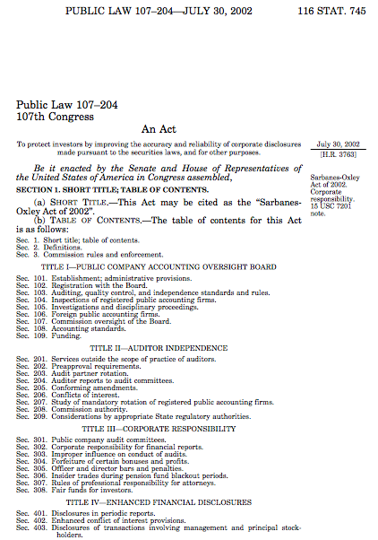

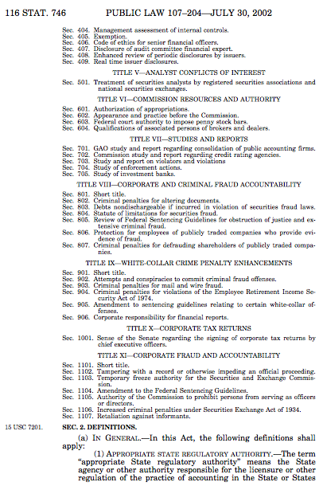

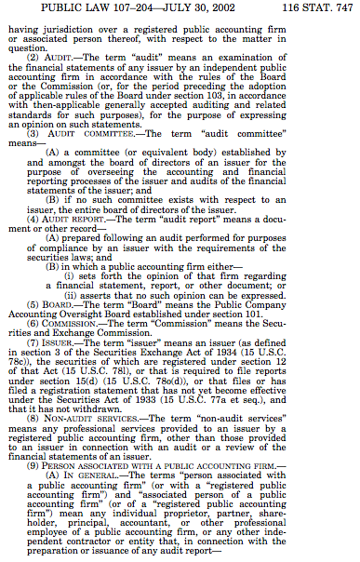

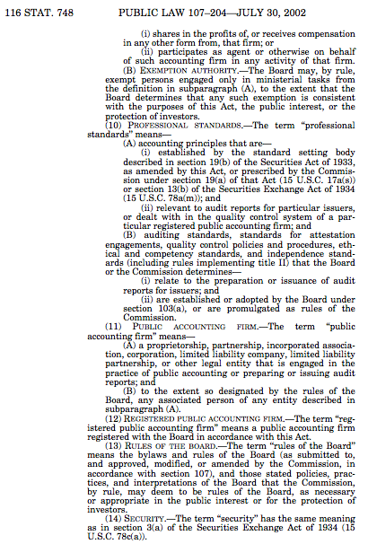

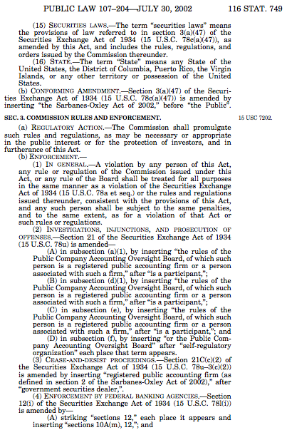

Appendix II
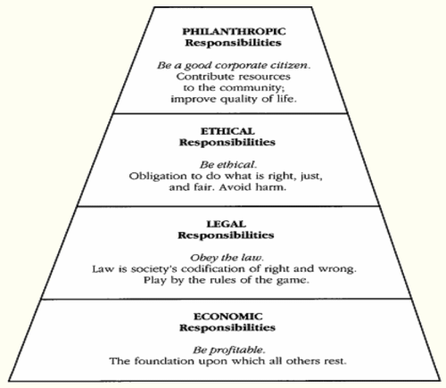
Figure 1: Archie Carroll’s Pyramid of CSR

References
Act, S. O. (2002). Sarbanes-Oxley Act. Washington DC.
Carmichael, D. R. (2004). The PCAOB and the social responsibility of the independent auditor.
Accounting Horizons, 18(2), 127-133.
Carney, W. J. (2006). Costs of Being Public after Sarbanes-Oxley: The Irony of Going Private,
The. Emory LJ, 55, 141.
Carroll, A. B. (1991). The pyramid of corporate social responsibility: Toward the moral
management of organizational stakeholders. Business horizons,34(4), 39-48.
Coates, J. C. (2007). The goals and promise of the Sarbanes-Oxley Act. The Journal of
Economic Perspectives, 21(1), 91-116.
Friedman, M. (2007). The social responsibility of business is to increase its profits (pp. 173-
178). Springer Berlin Heidelberg.
Healy, P. M., & Palepu, K. G. (2003). The fall of Enron. The Journal of Economic Perspectives,
17(2), 3-26.
Jasso, S. (2009). Sarbanes-Oxley–Context & Theory: Market Failure, Information Asymmetry,
& the Case for Regulation. Journal of Academy of Business and Economics, Volume 9 (3)
Jasso, S. (2010). The Hippocratic Oath of the Manager: Good or Bad Idea? Philosophy for
Business, (Issue 56).
Porter, Michael and Kramer, Mark. (2011) Creating Shared Value: How to Reinvent
Capitalism and Unleash a Wave of Innovation and Growth. Harvard Business Review,
Jan/Feb), 63-77.
Rangan, K., Chase, L., & Karim. S. (2015). The Truth About CSR. Harvard Business Review,
93(½), 40-49
Romano, R. (2004). The Sarbanes-Oxley Act and the making of quack corporate governance.
Sarbanes, P. (2002, July). Sarbanes-Oxley act of 2002. In The Public Company Accounting
Reform and Investor Protection Act. Washington DC: US Congress.
Sims, R. R., & Brinkmann, J. (2003). Enron ethics (or: culture matters more than codes). Journal
of Business ethics, 45(3), 243-256.
SOX Law. (2002). A Guide to Sarbanes-Oxley Section 404." Sarbanes-Oxley Act Section 404.
Stemler, A. R. (2013). The JOBS Act and crowdfunding: Harnessing the power—and
money—of the masses. Business Horizons, 56(3), 271-275.
Williams, C. A. (1999). The securities and exchange commission and corporate social
transparency. Harvard Law Review, 1197-1311.

